**Bo Lin**

**ECE 579 Digital Control Systems**

# Test 2

(Due: April 15, 2016)

* Computer generated report is required for the test.
* Submit the report and all the MatLab related programs in one zip file.
* Present your design on April 11, 2016.

Design Problem:

It is possible to suspend a steel ball bearing by means of an electromagnet whose current is controlled by the position of the mass. A schematic of a possible setup is shown in the following figure. The equations of motion are

*mX*  *mg*  *f* (*X* , *I* )



where the force on the ball due to the electromagnet is given by *f(X,I)*. It is found that the magnet force balances the gravity force when the magnet current is *I0* and the ball at *X0*. If we write *I= I0*

*+ i* and *X = X0 + x* and expand *f* about *X = X0* and *I= I0*, and then neglect higher-order terms, we obtain a linear approximation

*mx*  *k*1*x*  *k*2*i* .



Values measured for a particular device in the Stanford Controls Laboratory are *m*=0.02kg, *k1*=20N/m, *k2*=0.4N/A.

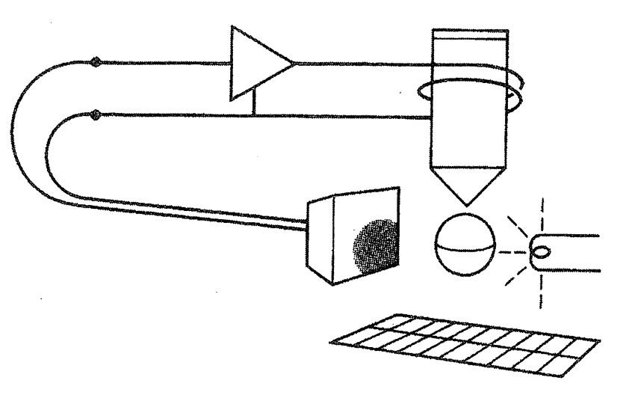

Fig. 1. A steel ball balanced by an electromagnet

1. (10) Conduct an online research for the related control problem. Explain and report clearly the principle, objective, setup etc. associated with the control problem
2. (10) Compute the transfer function from *i* to *x* and draw the continuous root locus for proportional feedback *i=-Kx*.
3. (10) Let the sample period be T=0.02sec and compute the plant discrete transfer function when used with a sample and zero-order hold.
4. (15) Design a digital controller for the magnetic levitation to meet the specifications tr0.1sec, ts0.4sec, and overshoot  20%.
5. (10) Plot a root locus of your design versus *m* and discuss the possibility of balancing balls of various masses.
6. (15) Plot a step response of your design to an initial disturbance displacement on the ball and show both *x* and the control current *i*. If the sensor can measure *x* over a range of only 0.5cm, and if the amplifier can provide a maximum current of 1A, what is the maximum initial displacement, *x(0)max* that will keep the variable within these limits, using *m*=0.02kg?
7. (10) Verify your design with a discrete simulation using Simulink, in which both controller and plant have the same simulation time.
8. (10) Verify your design with a mixed signal simulation using Simulink, in which controller and plant have the different simulation time, i.e., plant “continuous” while the controller “discrete” with specified sampling rate.
9. (10) Imagination or addition of your own thought and idea
10. (10) Project report and presentation.

a) A team of Stanford-based researchers showed in a paper about magnetic levitation published in the Proceedings of the National Academy of Sciences(PNAS). They used a 2-inch-long device made of two magnets affixed with plastic, the team showed it’s possible to levitate individual cells.[1]

A cooperation work from MIT Department of Mechanical Engineering and Department of Electrical Engineering and Computer Science shows a design of low-cost magnetic levitation project kits for teaching feedback system design. In this system, the position of the levitated object is sensed by a Hall-effect sensor. The output voltage of the sensor drives the input of a low-cost fan-management chip, which produces a pulse-width modulated (PWM) drive signal to a motor drive chip. This PWM signal adjusts the average current in the solenoid, which controls the magnetic field. Damping is provided by some washers attached to the levitated object. Losses and eddy currents in the ferrous material help to dampen the vertical wobble of the object.[2]

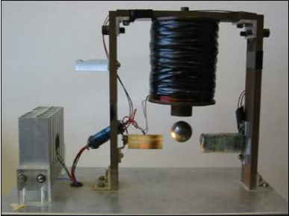 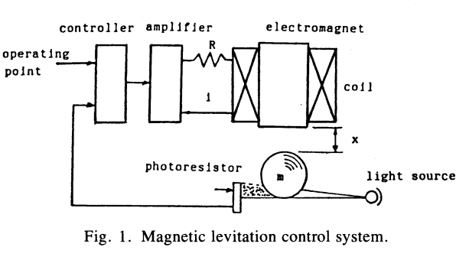

Figure 1 Magnetic levitation control system

The above device in MIT was originally invented by T.H.Wong. In his original system, a ball bearing of mass m is placed underneath the electromagnet at distance x. The current flowing into the electromagnetic coil will generate electromagnetic force to attract the ball bearing. The net force between the electromagnetic force and gravitational force will induce an up or down motion of the ball bearing. The photoresistor senses the variation of the position of the ball bearing by the amount of shadow casted on its surface and feeds back this signal to the control circuit and amplifier to regulate the input current i. The ball bearing is kept in a dynamic balance around its equilibrium point. [3]

The system’s dynamic equations can be obtained as



where C is a constant, R and L are coil resistance and inductance, the other parameters are given in the question.

The system block diagram is :

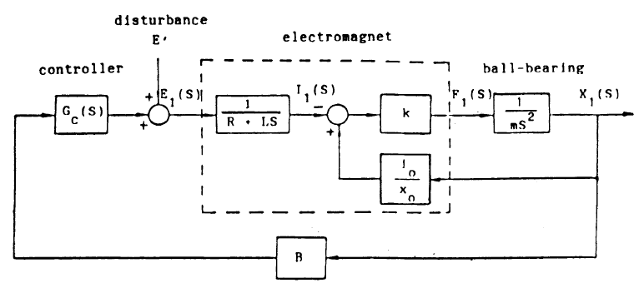

Figure 2 Block diagram of original system

b)





Figure 3 Root locus of continuous plant

c)

T=0.02 sec





Figure 4 Root locus of discrete plant

d)



Based on the requirements above, design a lead compensator initially as

   
In order to have a fast rise time, the pole should be closer to the imaginary axis. Apply the zero to cancel the pole in the original plant. so a=0.5313.

For b, choose a new pole near the imaginary using while inside the  zone given by the above limitations will satisfy the requirements.



Figure 5 Root locus of discrete controller and plant finding right gain



Figure 6 Detail zoom in of the root locus

After plotting the root locus diagram, find the proper gain along the line which has an overshoot less than 20% and frequency larger than 23rad/sec. Near the edge of the ZGRID zone, only a small area satisfy the requirements where the gain is 116 shown in the above graph.

So finally 

Performance:



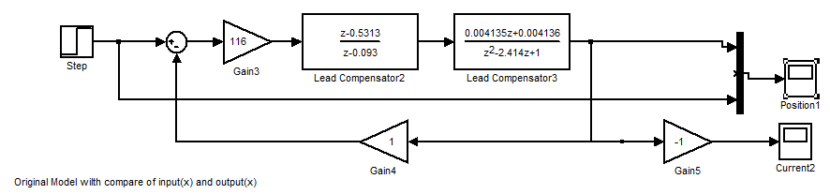

Figure 7 System Simulink Model

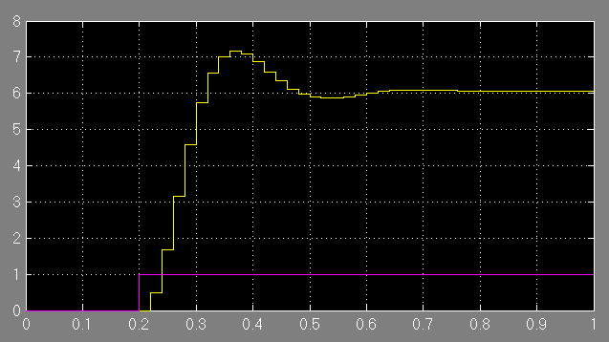

Figure 8 Simulink Result of step response



Figure 9 Continuous position result

e)



Fix the k1,k2, and change m from 0.001 to 0.1kg.

Plot the poles for  ,which is the zeroes for  using ‘roots’



Figure 10 Mass trace poles in z grid

When starting from m=0.01, the pair of poles starts from the outside of the Z unit circle, and the middle blue one start from the right to the left. The first pair of poles that locate inside the circle is  , which is m=0.08kg. For  , the system is stable as long as the power is under the limitation.

In addition, if plot root locus versus k1,



Figure 11 K1 tracking poles in z grid

We can see in the red dot trace that when k1 is larger than 23.9, it exceed out of the zgrid unit circle which means the system will be unstable.

f)

Add an initial position into the Simulink Model using the impulse block.

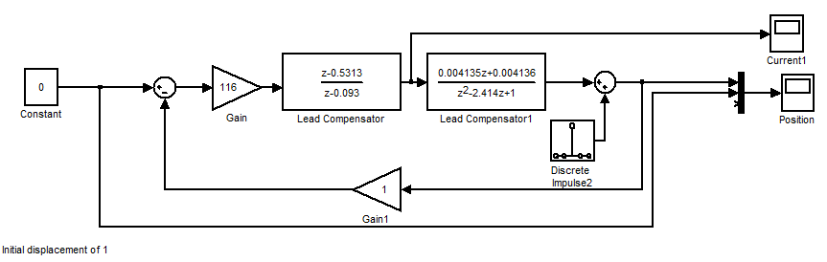

Figure 12 Inpuse as initial displacement input



The range given in the question is ,which is inside the range for i(0)=1.So for any initial displacement, the system will always stay below the current limit. Add an initial position as impulse into the system in Simulink.

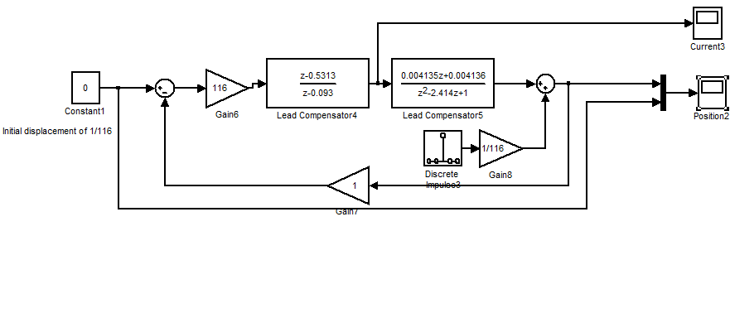

Figure 13 Initial Maximum displace ment of 1/116 m

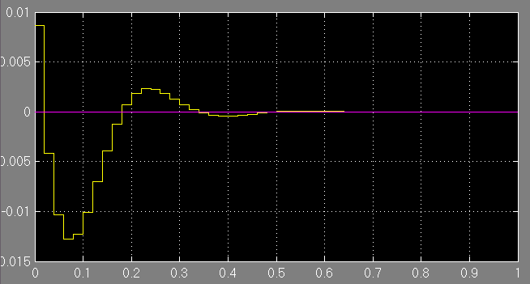

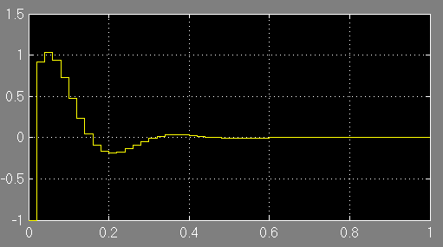

Figure 14 Control Current for maximum displacement

From figure 14, applying maximum displacement, the current i(0) is -1 A, however the overshoot is a little bit over 1 A. But for range of 0.5cm, it will satisfy.

For displacement of 0.5 cm, the current is within the limit of 1 A.

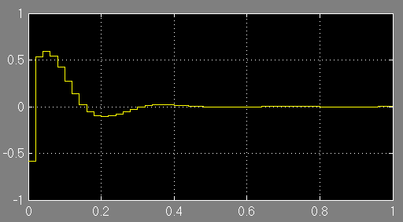

Figure 15 Control Current of Initial displacement of 5cm

g) Shown in Simulink file with same Ts. Figures are shown above.

h)

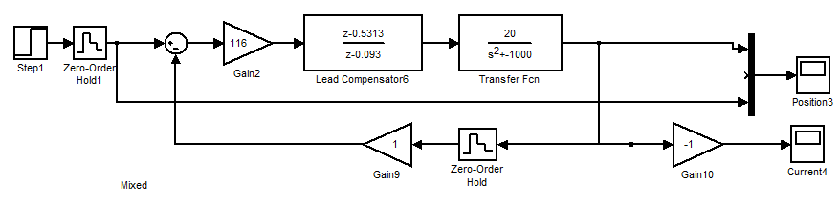

Figure 16 Discrete compensator with continuous plant

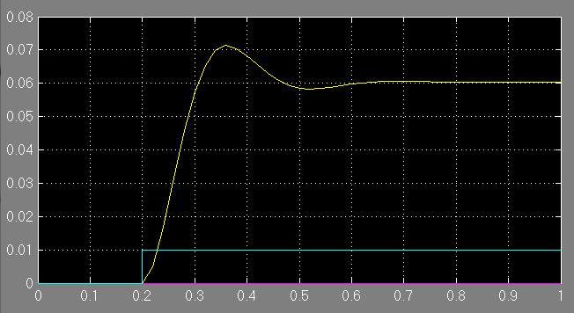

Figure 17 Step input result for position x

i)Own thoughts

a)For step response, there is a phenomenon that output is six times the input value. That is because from the system’s original block diagram, the input value in reality is the E1(s) which is the voltage and the output is position X(s).

b)After voltage go through the  block voltage turned into current. However in the question, the plant is applied with a simplified equation

*mx*  *k*1*x*  *k*2*i* .

in the function, ,the k1 and k2 is related with i(0)and x(0), if we change the x(0), the k1and k2 will change , so for a system with different initial x, the k1 and k2 should be different.



c) In the feedback loop, the i=-kx. so the feedback should go to the electromagnet part, but for real situation it should go to the controller input which is voltage. The controller controls the voltage.

Reference

1. Naside Gozde Durmus,et al.(2015) Magnetic levitation of single cells. *Proceedings of the National Academy of Sciences.*E3661-E3668.

2.Katie A. Lilienkamp, Kent Lundberg.(2004) *The 2004 American Control Conference*.

3. T.H. Wong, Design of a magnetic levitation control system – an undergraduate project, *IEEE Transactions on Education*, vol. 29, November 1986, pp. 196–200.

4. J. Cicon, Building a magnetic ball levitator, *Popular Electronics*, vol. 13, no. 5, May 1996, pp. 48–52, 78.